|  |  |  |
| --- | --- | --- |
| **CL-1002 Programming Fundamentals** | **LAB 07**  **ITERATIVE STATEMENTS IN C** | |
|  | |  |

**NATIONAL UNIVERSITY OF COMPUTER AND EMERGING SCIENCES**

**Learning Objectives**

1. Iteration & iterative statements in C
2. While loop
3. Do-while loop
4. For loop
5. Continue Statement
6. Break Statement
7. Nested Loops
8. **Iteration and Types of Iterative C**

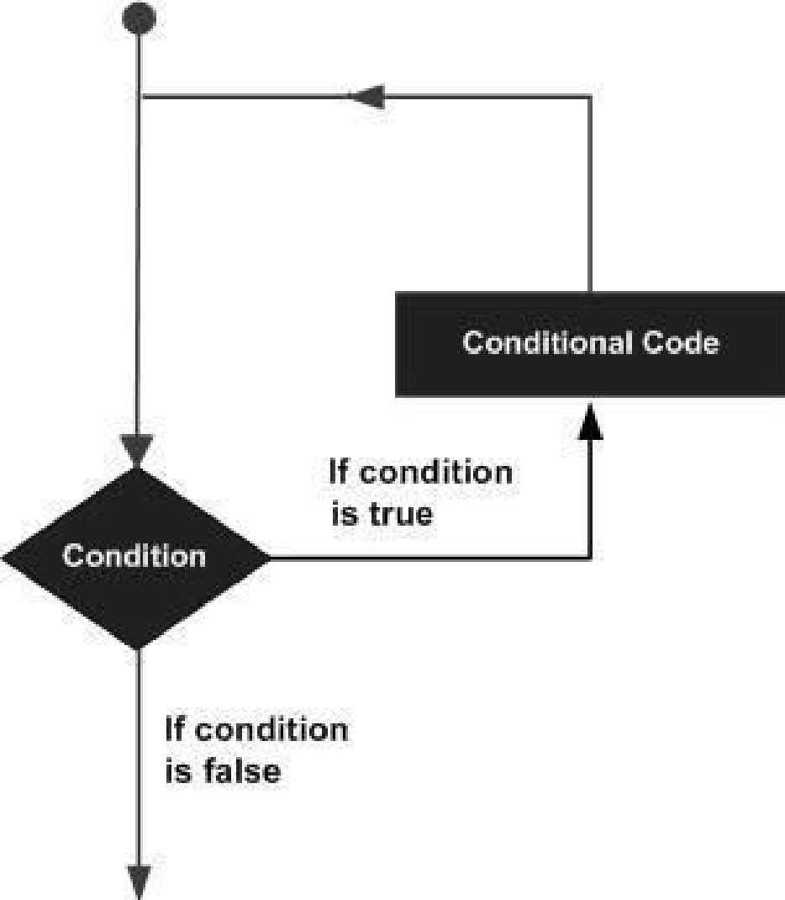By iteration or repetition, we mean doing the same task again and again. Usually, we want to repeat the task until some condition is met or for a predefined number of iterations. In computer science this is commonly referred as loop. Loops are used to repeat a statement, a block, a function or any combination of these. A typical looping workflow is shown in the figure.

Loops are very powerful and important tool in programming. Consider adding the salary of 1000 employees of a company. Or finding out how many people have been vaccinated from a list of 30 million people, that is just the population of Karachi what about whole Sindh or Pakistan? One way is to copy paste the code or repeating the lines of code. Well, the easier way is using a loop.

C programming language offers three kinds of iterative statements.

**Types of Loops**

1. While Loop
2. Do-while Loop
3. For Loop
4. **While Loop**

The while loop is usually used when we don’t know the number of iterations in advance.

**Application:** As a game developer you don’t have any knowledge how many times user will play the game so you want to loop over the choice if they want to play again or not.

* 1. **C- Syntax**

**while ( loop repetition condition )**

**{**

**Body of the loop.**

**}**

* 1. **Interpretation:**
* The loop repetition condition (a condition to control the loop process) is tested; if it is true, the statement (loop body) is executed, and the loop repetition condition is retested.
* The statement is repeated as long as (while) the loop repetition condition is true. When this condition is tested and found to be false, the while loop is exited and the next program statement after the while statement is executed. If the condition is true forever the loop will run forever, we call such loop an infinite loop.
* It may not be executed at all if condition is false right from start.
  1. **Example:**

To count number of digits in a given integer.

**Input:** 13542

**Output:** 5

|  |  |
| --- | --- |
| **ALGORITHM** | **FLOWCHART** |
| 1. Start 2. Input number 3. count = 0 4. While number != 0 do 5. number=number/10 6. count = count + 1 7. While End 8. Print count 9. End | C:\Users\Solat\Downloads\Example#3.png |
| **C-IMPLEMENTATION** | |
| **#include <stdio.h>**  **int main()**  **{**  **int number=0, count =0;**  **scanf("%d",&number);**  **while ( loop repetition condition )**  **{**  **//Statement_Block;**  **}**  **while (number != 0)**  **{ number = number/10;**  **count = count + 1;**  **}**  **printf("The number of digits are: %d", count);**  **return 0;**  **}** | |

1. **Do-while Loop**

The do-while loop checks the loop repetition condition after running the body of the loop. This structure makes it most favorable in conditions where we are interested in running the body at least once.

**Application:** As a web-developer you are writing a registration application. You would like to make sure if the username is already taken or not. Therefore, you will keep asking for a unique username until provided, in such situations you would want the user to provide the username first and then perform the check.

1. **C- Syntax**

**do**

**{**

**Body of the Loop;**

**} while ( loop repetition condition );**

1. **Interpretation**

* First, the body of the loop is executed.
* Then, the loop repetition condition is tested if it is true, the body is again and the condition is retested until it remains true the loop continues. When this condition is tested and found to be false, the loop is exited and the next statement after the do-while is executed.

1. **Example**

Repeating the same example with do-while. Count number of digits in a given integer.

**Input:** 144452

**Output:** 6

|  |  |
| --- | --- |
| **ALGORITHM** | **FLOWCHART** |
| 1. Start 2. Input number 3. count = 0 4. do 5. number=number/10 6. count = count + 1 7. while number != 0 8. Print count 9. End | **G:\FAST-NUCES\ITC\Lab05\Untitled Diagram (3).png**  **do**  **while**  **number!=0**  **True**  **False** |
| **C-IMPLEMENTATION** | |
| **#include <stdio.h>**  **int main()**  **{**  **int number=0, count =0;**  **scanf("%d", &number);**  **do**  **{**  **//Statement_Block;**  **} while ( loop repetition condition );**    **do**  **{**  **number = number/10;**  **count = count + 1;**  **} while (number != 0);**  **printf("The number of digits are: %d", count);**  **return 0;**  **}** | |

1. **For Loop**

The **For** loop is mostly used when we want to iterate for a specific number of times.

**Application:** You are developing a first-person shooter game in the beginning of the mission user is given 3 lives only, you would like the character to revive if killed for 3 times only.

1. **C- Syntax**

**for ( initialization expression ; loop repetition condition ; update expression )**

**{**

**Body of the Loop;**

**}**

1. **Interpretation**

* The *initialization* is an assignment statement that is used to initialize the loop control variable with a value. This is the first statement to be executed in the loop and only run once.
* The *condition* is a relational expression that determines when the loop exits. This runs after initialization, and verified before every iteration.
* The update expression either *increment* or *decrement* the loop control variable on each iteration.

1. **Example**

Print the numbers from 0 to desired value as shown below.

**Input:** 10

**Output:** 0 1 2 3 4 5 6 7 8 9 10

|  |  |
| --- | --- |
| **ALGORITHM** | **FLOWCHART** |
| 1. Start 2. Input stop 3. FOR next = 0 to stop 4. Print next 5. next = next + 1 6. END FOR 7. End | C:\Users\solat\Downloads\Untitled Diagram.png |
| **C-IMPLEMENTATION** | |
| **#include <stdio.h>**  **int main ()**  **{**  **int stop, next;**  **printf("Enter ending value:");**  **scanf("%d",&stop);**  **for (initialization expression ;**  **loop repetition condition ;**  **update expression )**  **{**  **//Statement_Block;**  **}**  **for(next = 0 ; next <= stop ; next=next+1)**  **{**  **printf("%d\t", next);**  **}**  **return 0;**  **}** | |
| **OUTPUT** | |
|  | |

**Comparison of Loops**

|  |  |  |  |
| --- | --- | --- | --- |
|  | **for** | **while** | **do-while** |
| **Initialization of condition variable** | In the parenthesis of the loop. | Before the loop. | Before the loop or in the body of the loop. |
| **Test condition** | Before the body of the loop. | Before the body of the loop. | After the body of the loop. |
| **Updating the condition variable** | After the first execution. | After the first execution. | After the first execution. |
| **When to use** | for is generally used when there is a specific number of iterations | while is generally used when the number of iterations is not known in advance. | do-while is a loop with a post-condition. It is needed in cases, when the loop body is to be executed at least once. |

1. **Continue Statement**

The continue statement is very powerful in situations where we want to execute some portion of the loop body and skip a statement or block of statements. The control skips the loop body as it reaches the continue statement and starts the next iteration. Usually there is a condition for which we want to skip certain statements.

**Application:** As an AI developer you would work with a lot of datasets (e.g., thousands of images). Before training your AI model on these datasets you need to filter the corrupted or invalid images from the valid once. In such situations you can utilize continue on dependent situations instead of using multiple conditional statements.

1. **C Syntax**

**for (initialization; condition; increment/decrement) {**

**block of statements; // this block will execute always with each iteration of loop**

**continue;**

**block of statements; // this block will be skipped.**

**}**

1. **Example:**

|  |
| --- |
| #include<stdio.h>  for(……….)  {  ……………..  If(condition)  continue;  …….  …….  }  int main()  {  int i;  for (int i=0; i<=10 ;i++)  {  if((i==3)||(i==7))  {  continue;  }  printf(“The sum is %d”, sum);  }  } |

1. **Break Statement**

Break statement is used to exit the body of the loop without meeting the loop repetition condition. The statement after the break never gets executed and usually break is used to stop the loop before the loop termination condition is met. The controls execute the next statement after the loop body once it reaches the break statement in the loop body. Usually there is a condition upon which we want to exit the loop.

**Application:** You have written a fund-raising application for a cancer patient, after the required funds are collected, you would like to break out of the loop without knowing how many iterations have passed.

1. **C Syntax**

**for (initialization; condition; increment/decrement) {**

**block of statements; // this block will execute always with each iteration of loop**

**break;**

**block of statements; // this block never gets executed.**

**}**

1. **Example**

|  |
| --- |
| #include<stdio.h>  for(……….)  {  ……………..  If(condition)  break;  …….  …….  }  printf(“…”);  int main()  {  int a, sum=0;  for(; ;)  {  scanf(“%d”,&a);  if(a==-999)  {  break;  sum=sum+a;  }  }  printf(“The sum is %d”, sum); |





**Nested For Loop**

* A for loop can contain any kind of statement in its body, including another for loop.
* The inner loop must have a different name for its loop counter variable so that it will not conflict with the outer loop.
* Nested loop: Loops placed inside one another, creating a loop of loops.

**IMPLEMENTATION IN C**

|  |
| --- |
| #include<stdio.h>  **for** ( *expr1a*; *expr2a*; *expr3a* )  **{**  **:**  **for** ( *expr1b*; *expr2b*; *expr3b* )  **{**  **:**  **}**  **:**  **}**  int main()  {  for (int i=1; i<=5;i++)  {  for (int j=1;j<=i;j++)  {  printf("*");  }  printf("\n");  } |

**LAB 07 EXERCISES**

**QUESTION# 01**

Write a C Program that takes any number from the user and identifies if the number is a perfect number or not.

**QUESTION# 02**

Write a program which will generate the Fibonacci series up to 10000. Also find the sum of the generated Fibonacci numbers divisible by 3, 5 or 7 only.

**Example of Fibonacci series is:** 1 1 2 3 5 8 13 25..........

**Note:** Do this task by using ***for loop*** **DO NOT** use arrays for this.

**QUESTION# 03**

Write a C Program to compute the LCM and GCD of two numbers

**QUESTION# 04**

Using For Loops take a value from the user and compute the possible prime numbers till that range

Input: 10

Output: 2,3,5,7

**QUESTION# 05**

Write a C Program to print the following pattern

**QUESTION# 06**

Consider Two integers a and b taken as input from the user. Using Loops iterate the value of a till the value of b.

If the value of a<=9 the output should correspond to the English representation of the numbers i.e., 8=Eight, 9=Nine etc.

If the iteration exceeds 9 then the programs should print if the exceeded number is even or odd

Input= 8,11

Output= Eight, Nine, Even, Odd

**QUESTION# 07**

Write a program to print out all armstrong numbers between 1 and 500. If sum of cubes of each digit of the number is equal to the number itself,then the number is called an Armstrong number.

Example: 153 = (1*1*1)+(5*5*5)+(3*3*3)

**QUESTION# 08**

Write a C program that produces the following output:

Note: Only use single loops **(No Nested Loops)**

**QUESTION# 09**

Write a program for a match-stick game between the computer and a user. Your program should ensure that the computer always wins. Rules for the game are as follows

* + - 1. There are 21 matchsticks.
      2. The computer asks the player to pick 1,2,3 or 4 match sticks
      3. After the person picks, the computer does its picking.
      4. Whoever is forced to pick up the last matchstick loses the game

**QUESTION# 10**

Write a program to produce the following output using loops

1 2 3 4 5 4 3 2 1

1 2 3 4 4 3 2 1

1 2 3 3 2 1

1 2 2 1

1 1